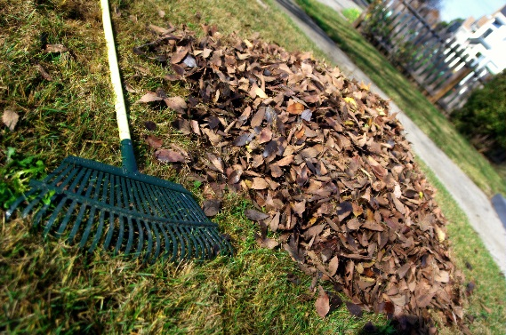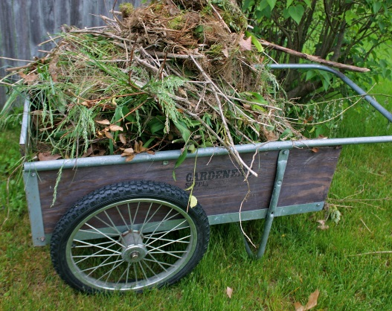

**Important notice: The City has discontinued the sale of Yard Waste bags. The green Yard Debris labels for barrels will still be offered free of charge and are available at City Hall or at the Public Works Complex on Commercial Way.**

For more information contact the Recycling

office at 435.7710 or 435-7701.

Department of Public Works/Refuse & Recycling Division, announces that the Forbes Street Compost Site will be open to residents on the following days

**from 8:00 AM to 3:00 PM**

**March 7, 14, 21, and 28, 2020**

 Residents may drop off leaves, grass and other vegetative material suitable for composting at the site. Residents must show a valid driver’s license as proof of residency.

**No commercial vehicles are permitted.**

Incoming material must be loose; no plastic bags,

no contaminates, no trash or fencing material.

**Weekly curbside yard waste collection will resume**

**Beginning the week of March 30, 2020**

Forbes Street Compost Area

2020 dates for

Leaf and Yard

Waste Drop Off