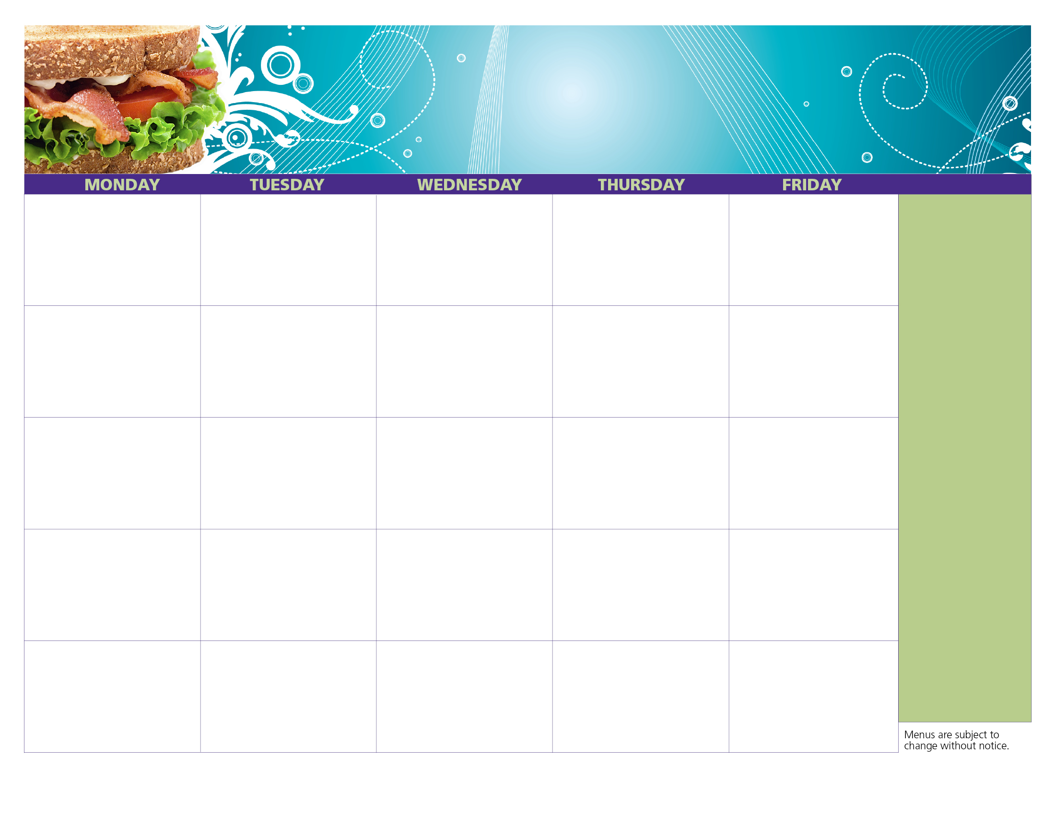

Chicken Patty Sandwich

Applesauce Cup

Fruit Punch

Milk

Chicken Drumstick

Goldfish Pretzels

Mixed Fruit

Broccoli

Milk

Taco Dippers

w/ Salsa

Baby Carrots

Strawberry Cup

Milk

Rib-B-Que

Fresh Orange

Mango Tango Juice

Milk

Mozzarella Sticks

w/ Marinara

Fresh Apple

Dragon Punch

Milk

Bagel

w/ Cream Cheese

2 String Cheese

Applesauce Cup

Fruit Punch

Milk

Soft Pretzel

String Cheese

Yogurt

Applesauce Cup

Fruit Punch

Milk

Chicken Tenders

w/ Dinner Roll

Mixed Fruit

Broccoli

Milk

Beef Ravioli

w/ Breadstick

Fresh Apple

Dragon Punch

Milk

Hot Dog

Fresh Pear

Mango Tango Juice

Milk

Chicken Nachos

w/ Salsa

Baby Carrots

Peach Cup

Milk

**No Meal Service**

**VJ Day**

Cheeseburger

Orange

Mango Tango Juice

Milk

Beef Nachos

w/ Salsa

Baby Carrots

Strawberry Cup

Milk

Popcorn Chicken

w/ Breadstick

Diced Pears

Cucumbers

Milk

**7**

**6**

**5**

**4**

**3**

We offer free, nutritious meals to all teens & children, 18 & under – no ID or paperwork required!

Come to any of our open sites.

Call

401-435-7511

for locations,

dates and times!

**All meals MUST be served with a milk.**

**4**

**East Providence Recreation Summer Lunch Program – Hot Lunch Sites**

**1**

**25**

**Healthy Kids. Healthy Communities. Healthy Rhode Island!**

**14**

**13**

**12**

**11**

**10**

**3**

**20**

**27**

**19**

**26**

**18**

**21**

**17**

**28**

**24**

**2**

**31**

**August**

**2020**